**DAILY ONLINE ACTIVITIES SUMMARY**

|  |  |  |  |  |  |  |  |  |
| --- | --- | --- | --- | --- | --- | --- | --- | --- |
| **Date:** | **27/06/2020** | | | | | **Name:** | **NIKHIL KUMAR** | |
| **Sem & Sec** | **4thSEM. & ‘B’ SEC.** | | | | | **USN:** | **4AL19CS400** | |
| **Online Test Summary** | | | | | | | | |
| **Subject** | | **DATA COMMUNICATION** | | | | | | |
| **Max. Marks** | | **30** | | **Score** | | | **27** | |
| **Certification Course Summary** | | | | | | | | |
| **Course** | **SQL and Relational Databases 101** | | | | | | | |
| **Certificate Provider** | | | **Cognitive class** | | **Duration** | | | **5hr** |
| **Coding Challenges** | | | | | | | | |
| **Problem Statement1 :Write a C++ program to print kth digit.**  Given two numbers a and b, find kth digit from right of a^b.  Input:  The first line of the input contains T denoting the number of test cases.Each of the next T lines contains three space separated positive integers denoting the value of a , b and k respectively.  Output:  For each test case, output the kth digit from right of a^b in new line.  Constraints:  1<=T<=100 1<=a , b <=15 1<=k<=|totaldigits in a^b|  Example:  Input: 2 3 3 1 5 2 2  Output: 7 2  Hint Output: 1 Explanation 3^3 = 27 for k = 1. First digit is 7 in 27 Output : 2 Explanation 5^2 = 25 for k = 2. First digit is 2 in 25 | | | | | | | | |
| **Status: Executed** | | | | | | | | |
| **Uploaded the report in Github** | | | | | **Yes** | | | |
| **If yes Repository name** | | | | | <https://github.com/Nikhil401/c-codding/blob/master/kth.cpp> | | | |
| **Uploaded the report in slack** | | | | | **Yes** | | | |

**Online Test Summary : Subject Data Communication test scheduled from 5th module from 11:30 to 12:00 pm. Number of questions was 30 and each carries 1 mark and the snapshot of test is given below :** 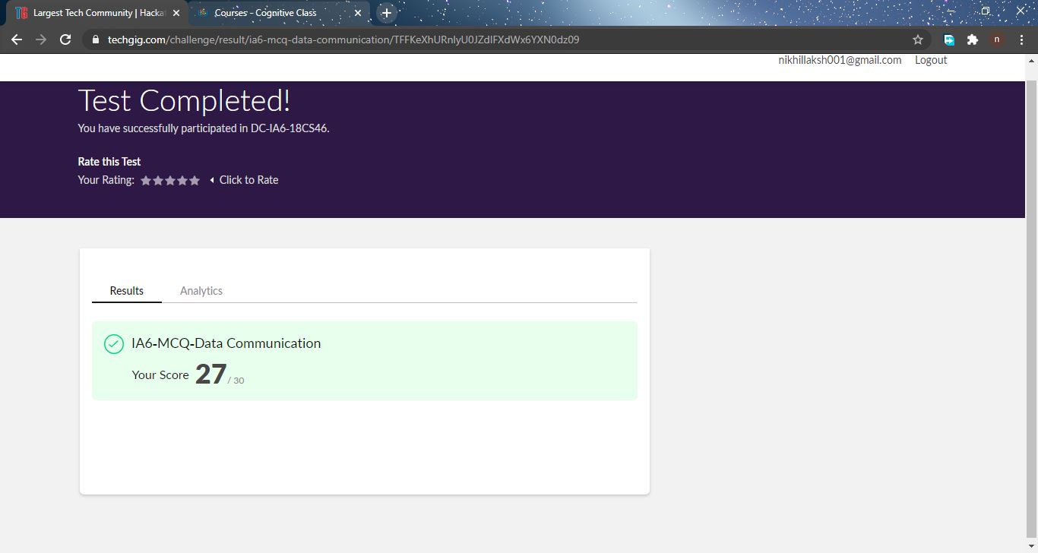

**Certification Course Summary: Today I have gone through the module2 which includes Relational model constraints introduction, Relational model constraints Advanced, Additional information with assignment2….**

**Snapshot is given below**

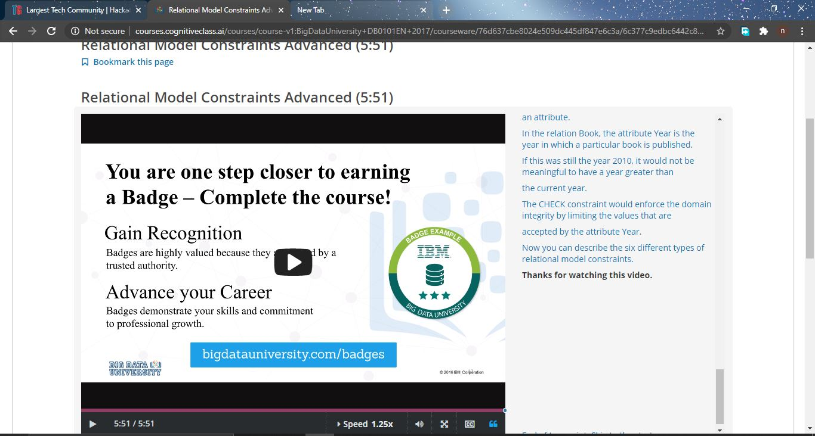

**Online Training : Today I had attended the online training organized by CSE Department AIET. The training was on C Programming done by prof. Megha hedge CSE Dept. After the session the quiz was conducted.**

**And the snapshot is given below**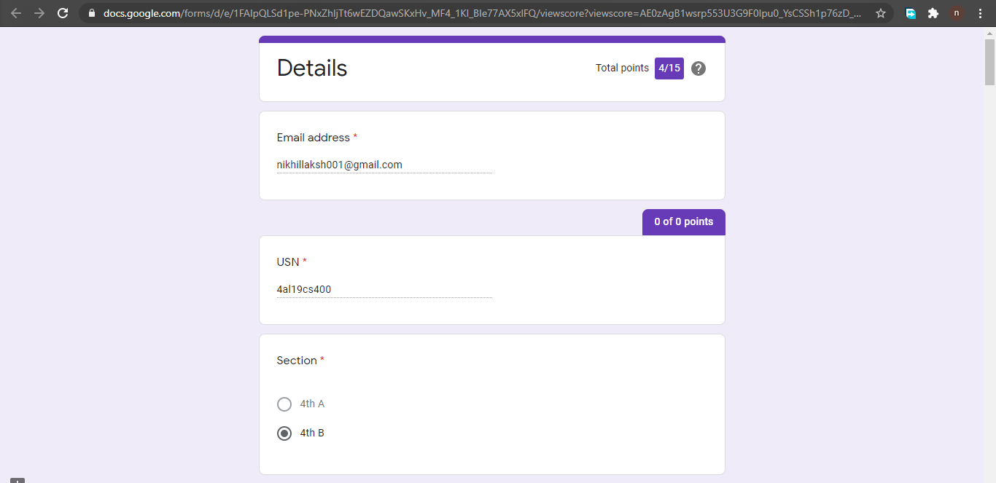

**Online coding summary: Today I had received one program which is mentioned in table above and I have uploaded into the github repository. Snapshot of the program is given below:** 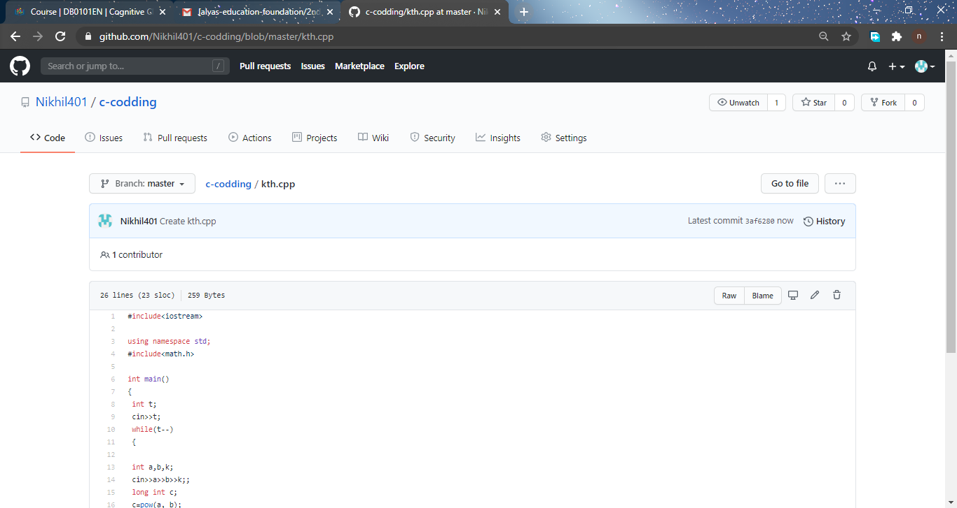

**Thank you.**